**Clustering the target scatter plots according to TFs’ family and Pearson correlation coefficient**

The bold text above plots indicates the family to which these TFs belong. Plots outlined by blue lines are selected to be the representative of family to constitute PBM_20. The TF name and Pearson correlation coefficient of binding intensities of paired TF are listed below plots.

All 66 TFs from the PBM data set were grouped by their families in general. In particular, TFs in the family, C2H2 ZF, were further divided into subgroups according to the Pearson correlation coefficient. Some TFs in different families with high PCC also clustered in the same group. The general cutoff of Pearson correlation coefficient is 0.4. As we can see, plots of TFs in different TF families has different patterns. In general, PBM_20 is the subset of PBM_66 without homologs.

The indicator of plots is below:

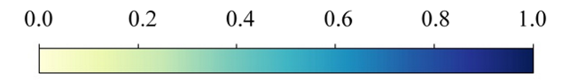

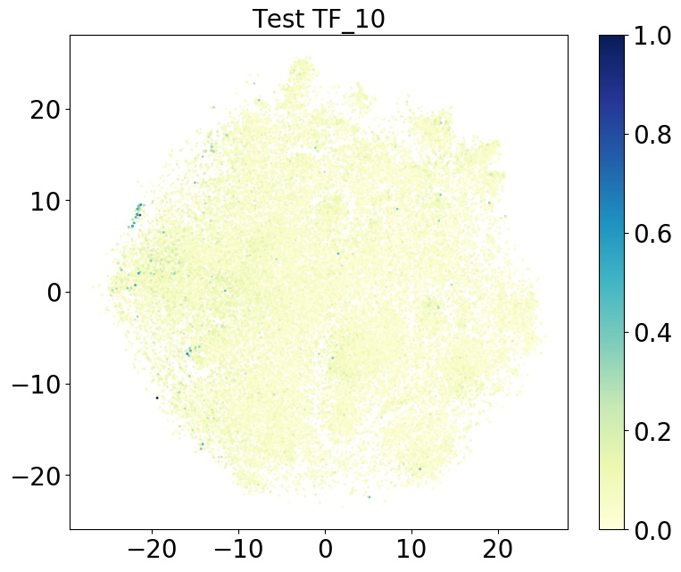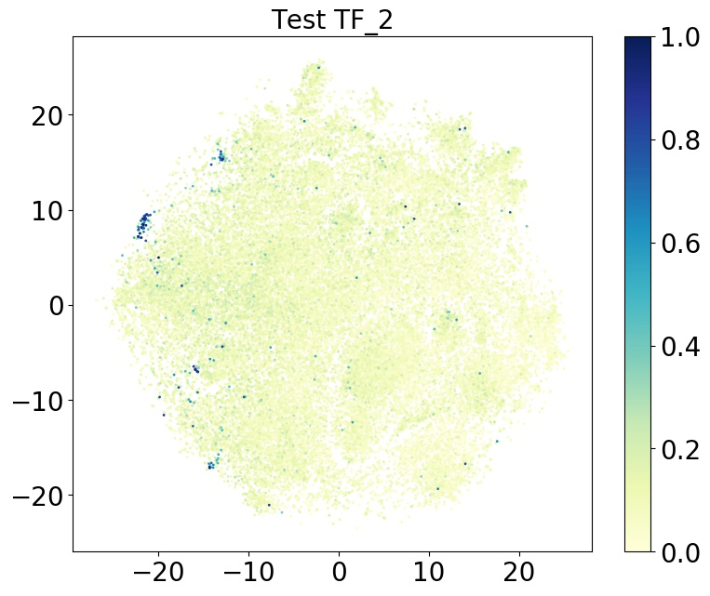**bZIP**

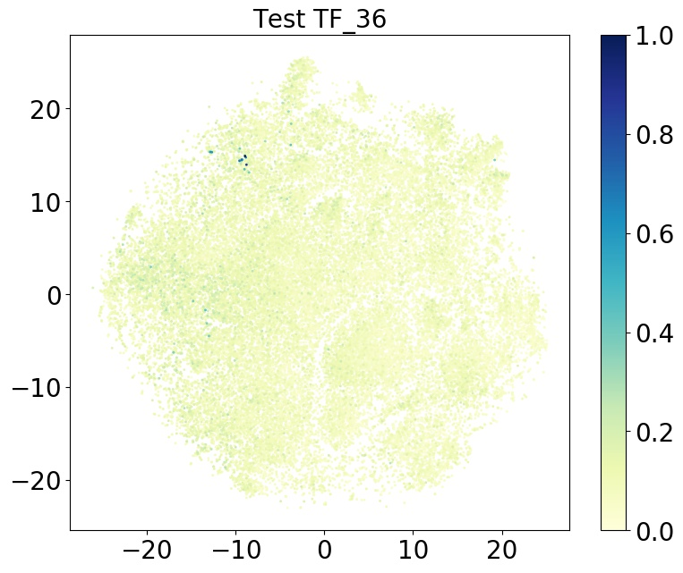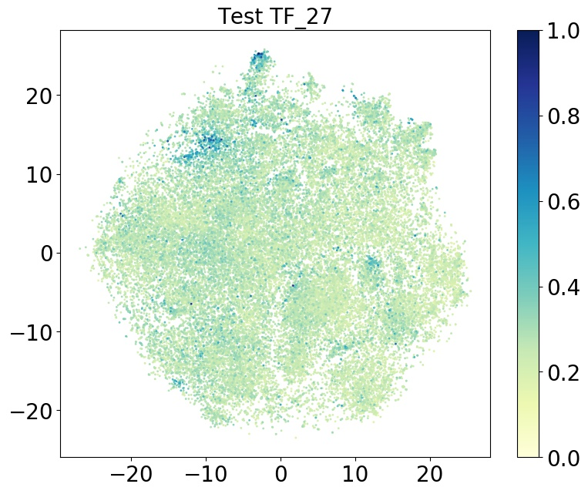

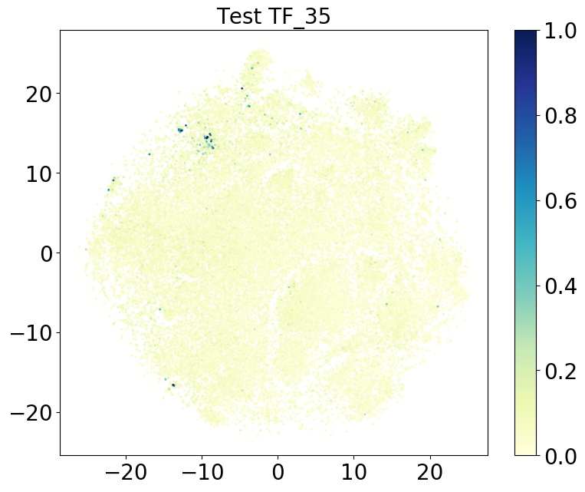

**TF_2: Dbp TF_10: Nfil3 TF_27: Xbp1 TF_35: Atf3 TF_36: Atf4**

TF_2, TF_35: 0.420 TF_2, TF_36: 0.506 TF_2, TF_10: 0.685

TF_2, TF_27: 0.342 TF_35, TF_36: 0.636 TF_10, TF_35: 0.462

TF_27, TF_35: 0.519 TF_10, TF_36: 0.586 TF_27, TF_36: 0.497

TF_10, TF_27: 0.339

**Forkhead**

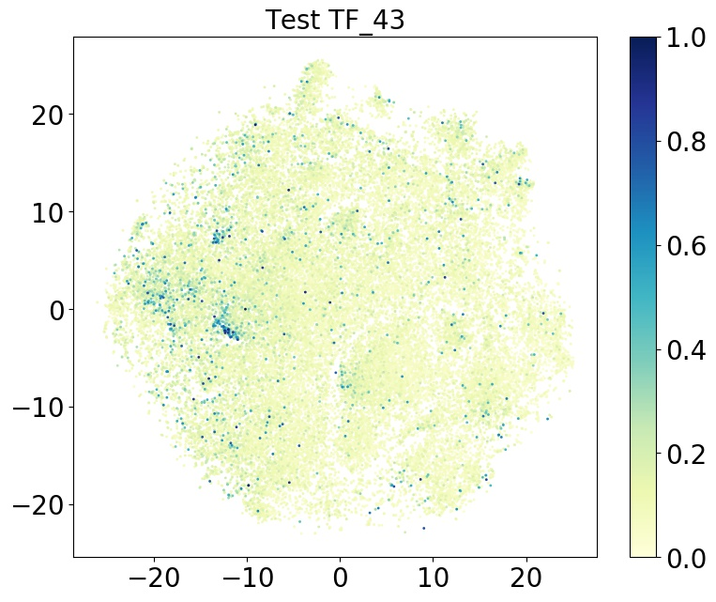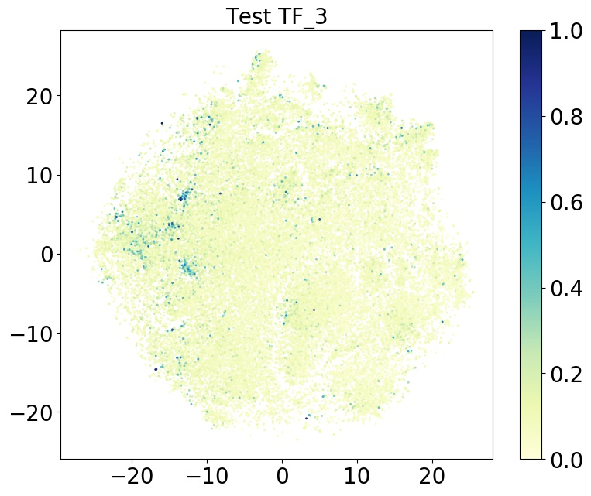

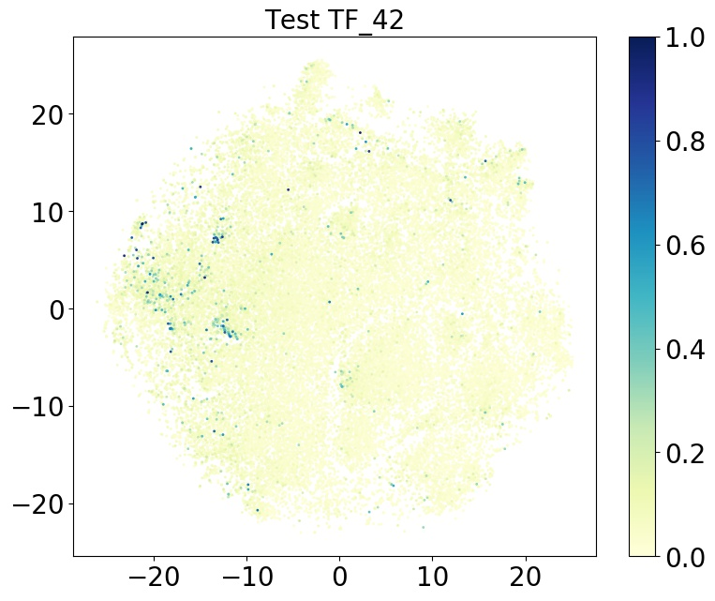

**TF_3: Foxo6 TF_42: Foxc2 TF_43: Foxg1**

TF_3, TF_42: 0.720 TF_3, TF_43: 0.784 TF_42, TF_43: 0.727

**C2H2 ZF**

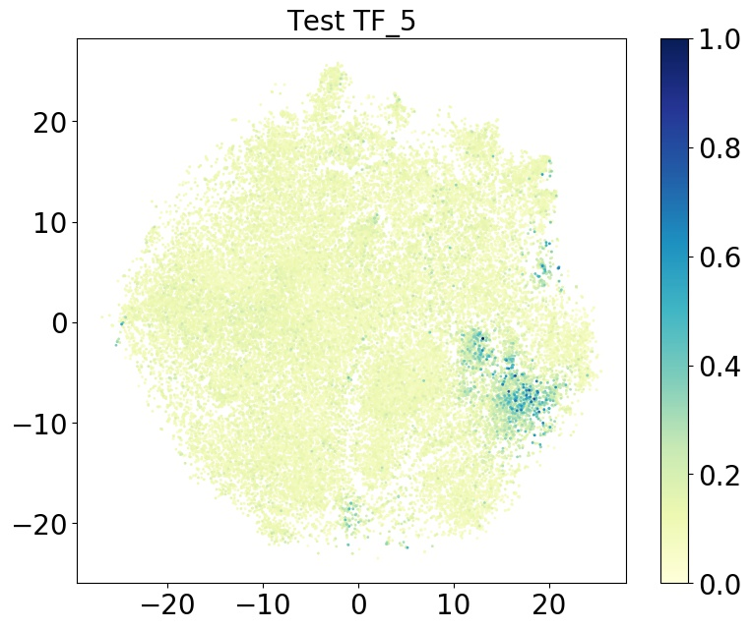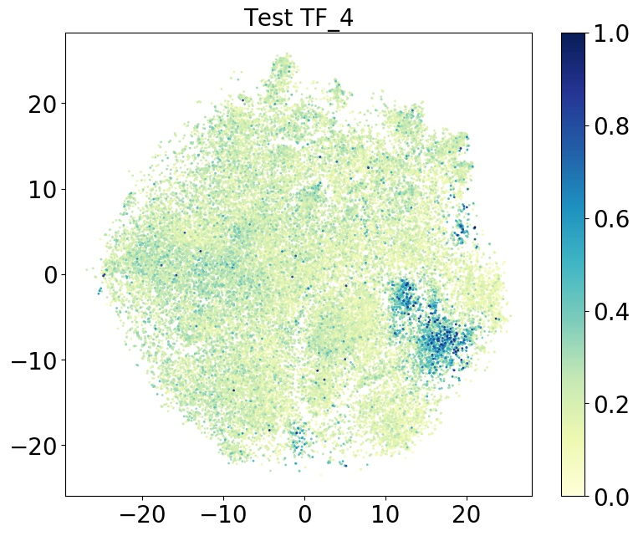

**TF_4: Klf12 TF_5: Klf8**

TF_4, TF_5: 0.707

**C2H2 ZF**

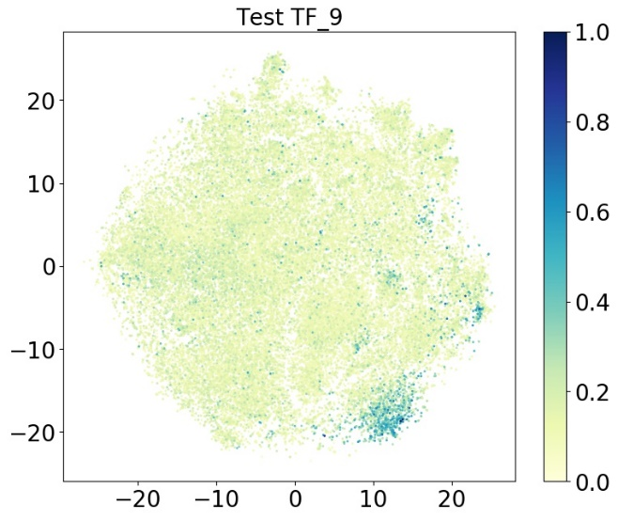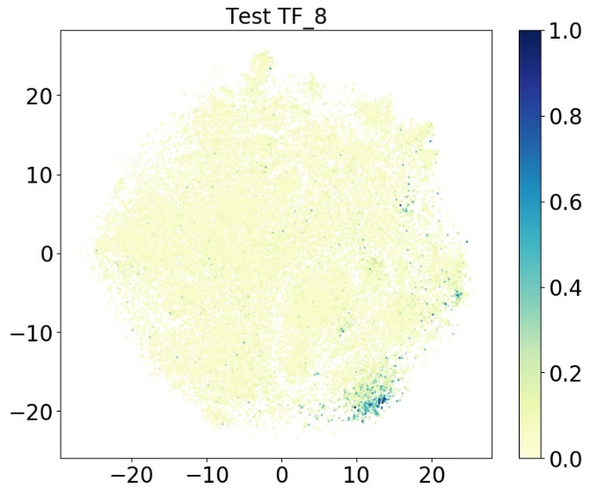

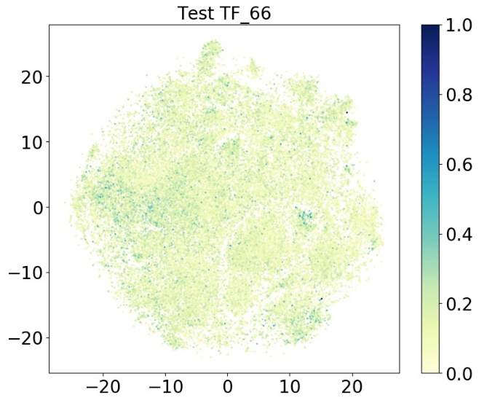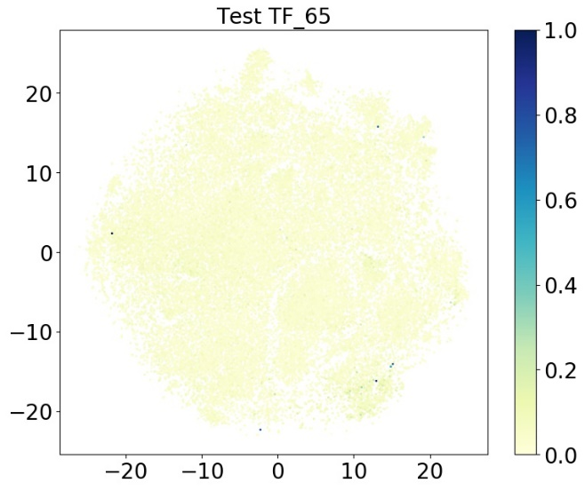

**TF_8: Mzf1 TF_9: Mzf1 TF_65: Zscan10 TF_66: Zscan10**

TF_8, TF_9: 0.728 TF_8, TF_65: 0.430 TF_8, TF_66: 0.480

TF_9, TF_65: 0.563 TF_9, TF_66: 0.692 TF_65, TF_66: 0.734

**C2H2 ZF**

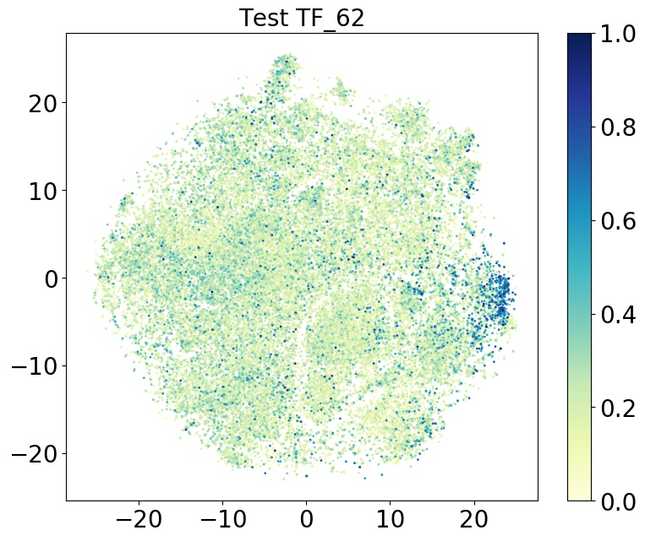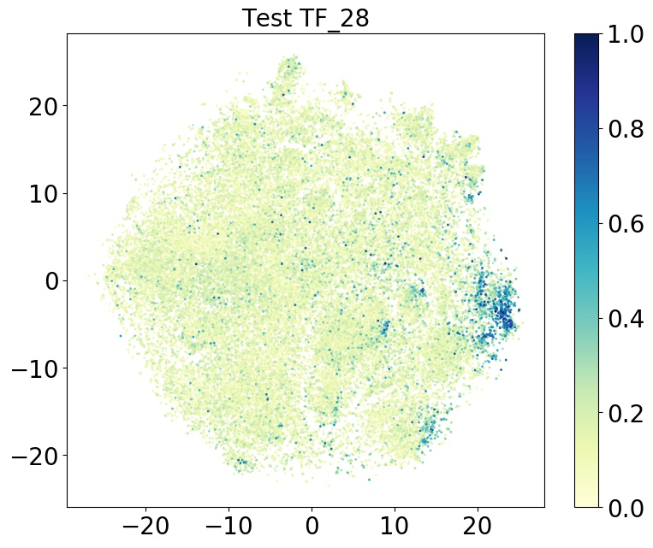

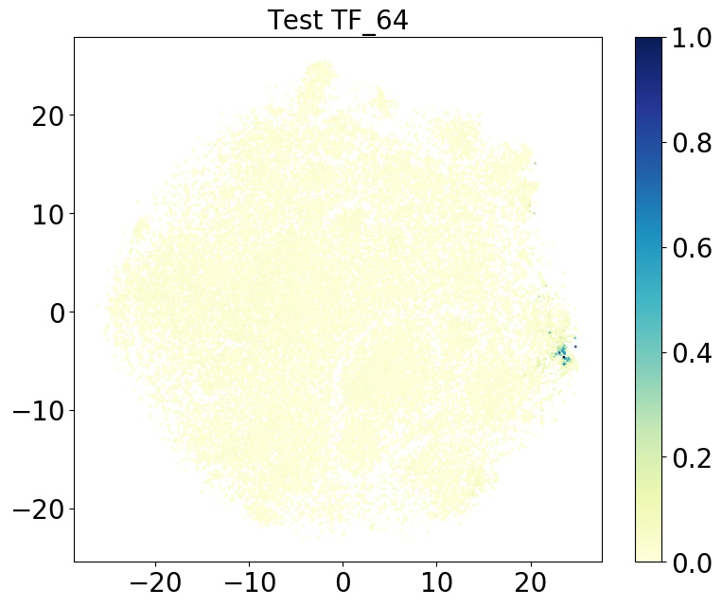

**TF_28: Zfp202 TF_62: Zic5 TF_64: Znf740**

TF_28, TF_62: 0.331 TF_28, TF_64: 0.512 TF_62, TF_64: 0.249

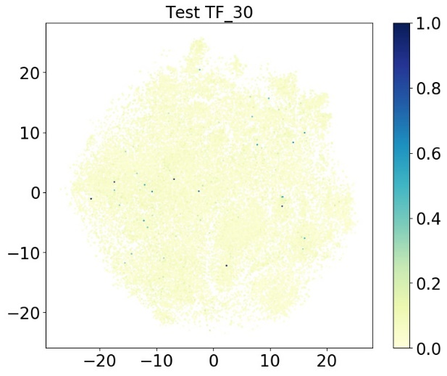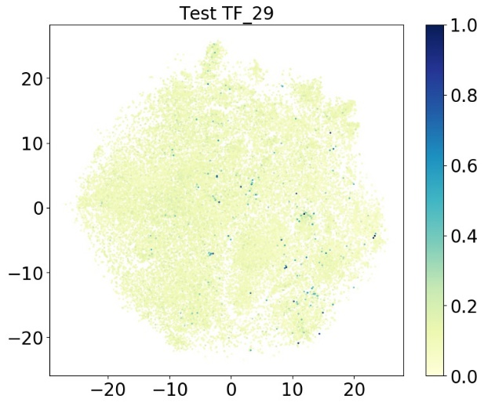**C2H2 ZF**

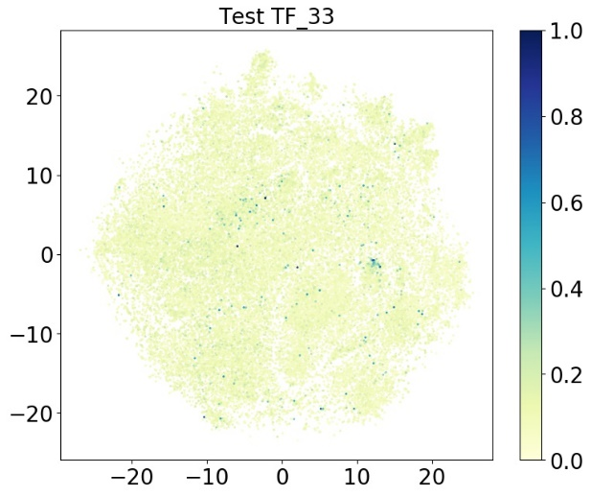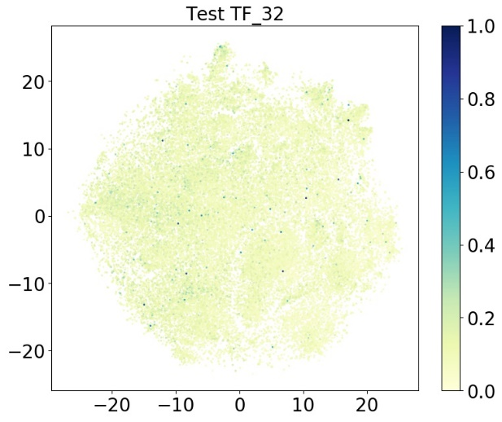

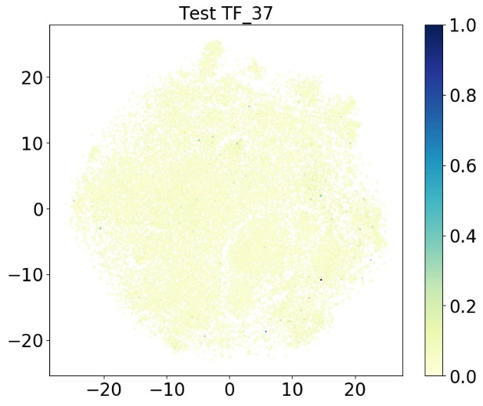

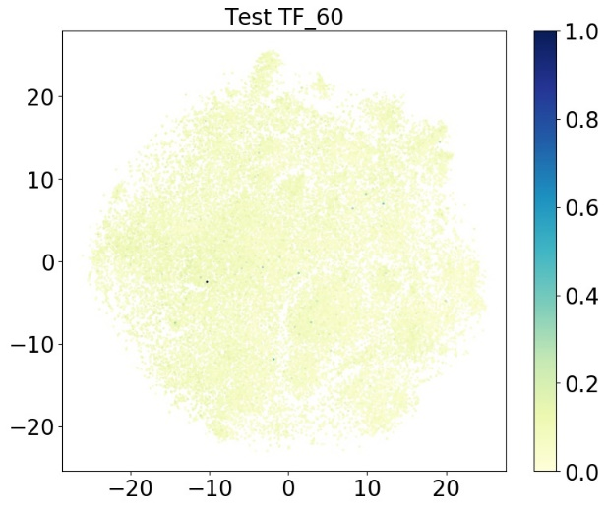

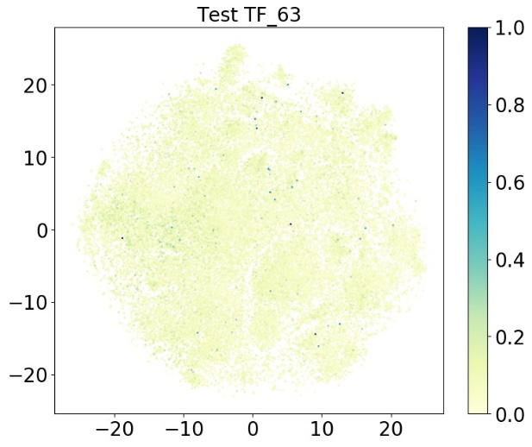

**TF_29 Zfp263 TF_30 Zfp3 TF_32 Zkscan1 TF_33 Zscan10**

**TF_37 chr15-10391820-10399583 TF_60 Zfp300 TF_63 Zkscan5**

TF_33, TF_37: 0.273 TF_33, TF_60: 0.566 TF_29, TF_33: 0.343

TF_30, TF_33: 0.467 TF_33, TF_63: 0.559 TF_32, TF_33: 0.465

TF_37, TF_60: 0.248 TF_29, TF_37: 0.170 TF_30, TF_37: 0.205

TF_37, TF_63: 0.278 TF_32, TF_37: 0.152 TF_29, TF_60: 0.283

TF_30, TF_60: 0.444 TF_60, TF_63: 0.634 TF_32, TF_60: 0.514

TF_29, TF_30: 0.222 TF_29, TF_63: 0.304 TF_29, TF_32: 0.240

TF_30, TF_63: 0.407 TF_30, TF_32: 0.371 TF_32, TF_63: 0.514

**C2H2 ZF (low similarity with others)**

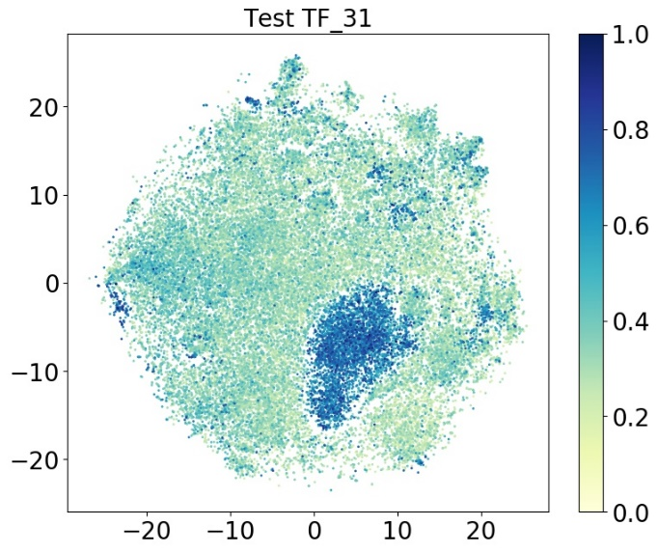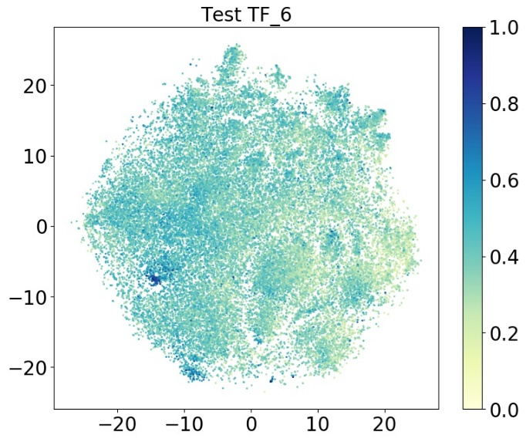

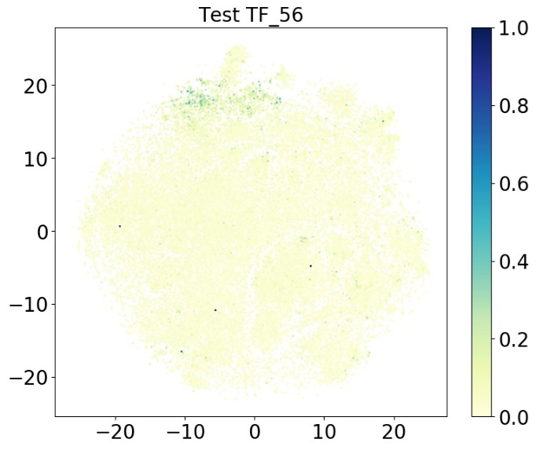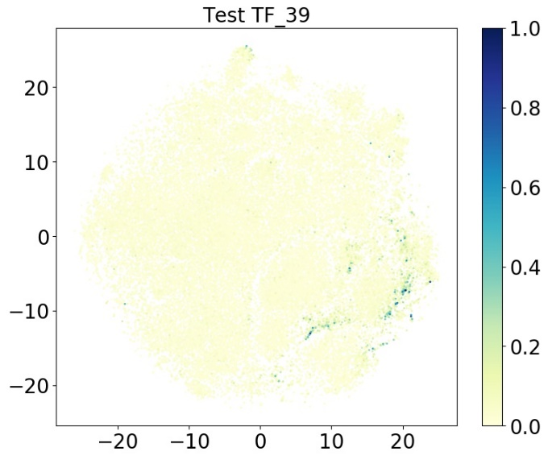

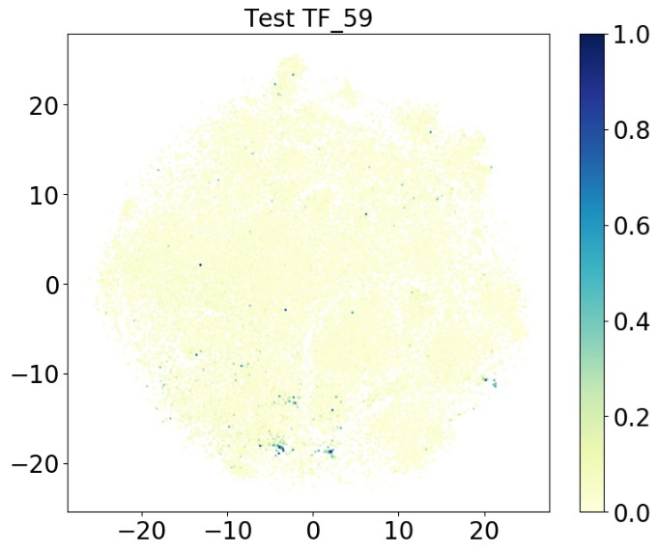

**TF_6: Klf9**

**TF_31: Zfx**

**TF_39: Egr3**

**TF_56: Snai1**

**TF_59: Zbtb1**

**Similar but in different families**

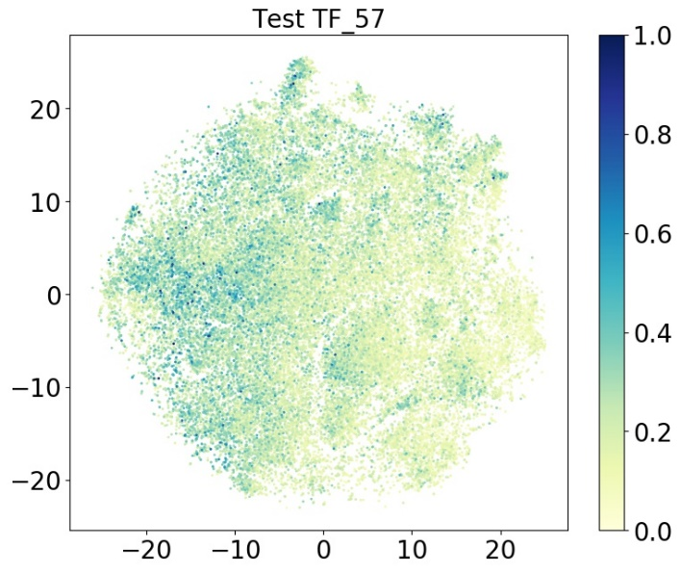**C2H2 ZF SAND**

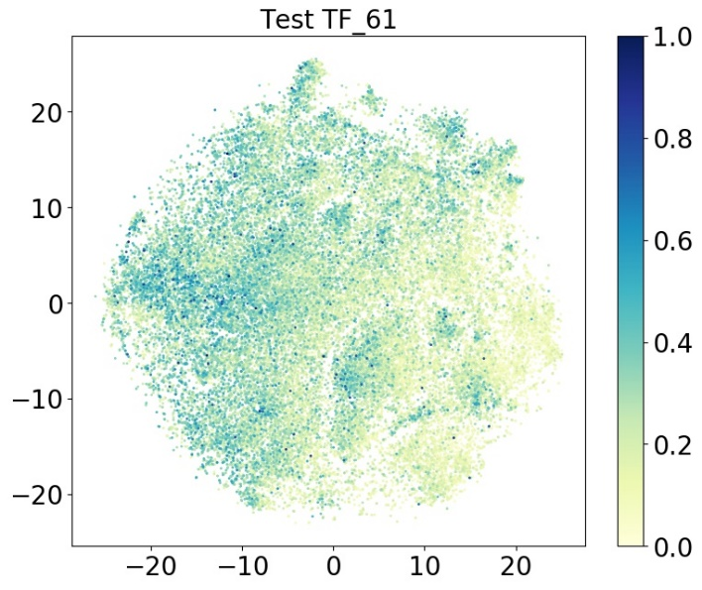

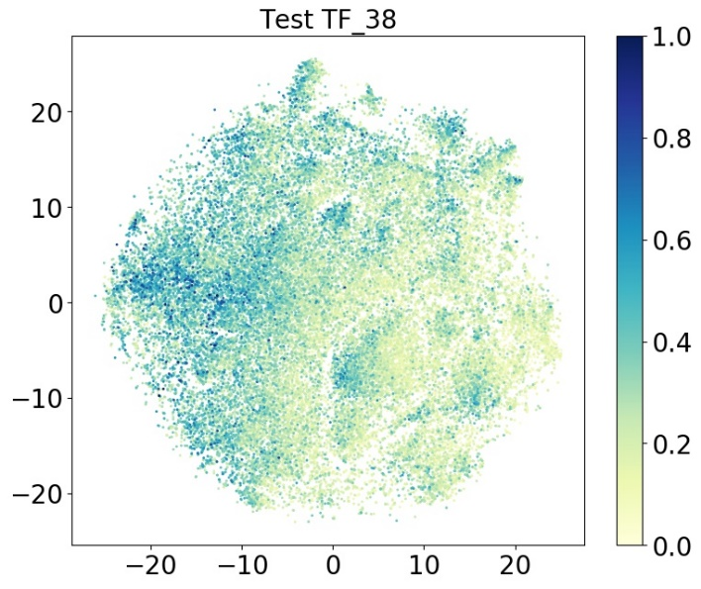

**DM**

**AT hook**

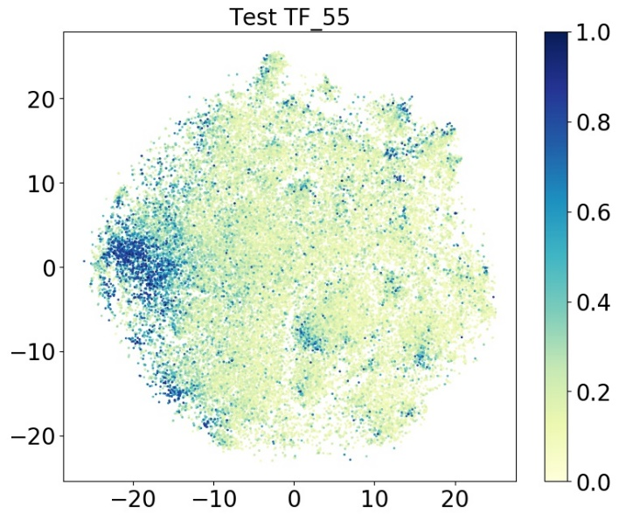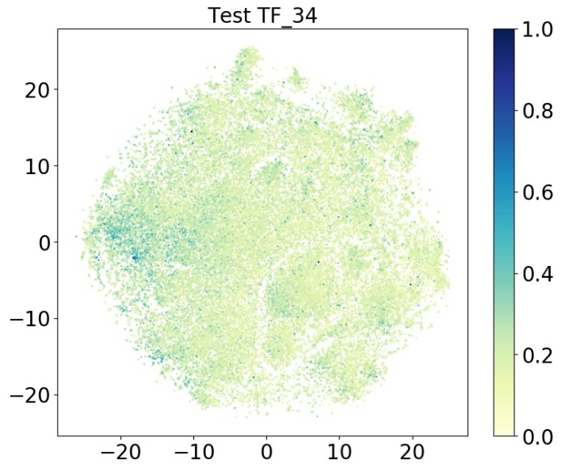

**DM**

**TF_38: Dmrtc2 TF_57: Sp140 TF_61: Zfp637**

**TF_34: Ahctf1 TF_55: Sdccag8**

TF_34, TF_38: 0.626 TF_34, TF_55: 0.667 TF_34, TF_57: 0.514

TF_34, TF_61: 0.488 TF_38, TF_55: 0.507 TF_38, TF_57: 0.644

TF_38, TF_61: 0.644 TF_55, TF_57: 0.502 TF_55, TF_61: 0.456

TF_57, TF_61: 0.688

**bHLH**

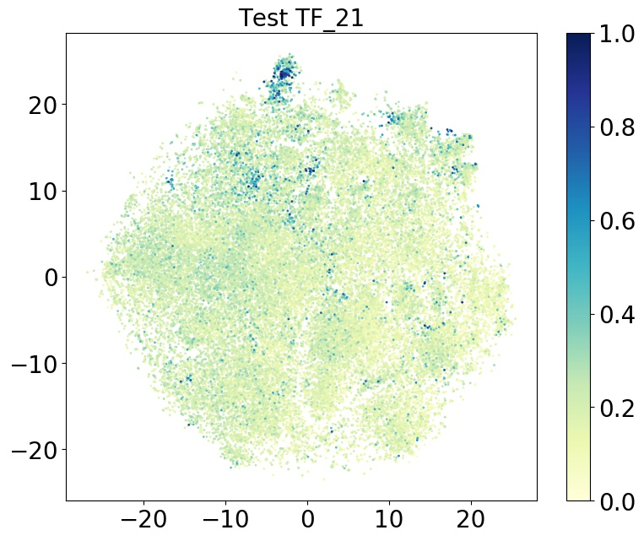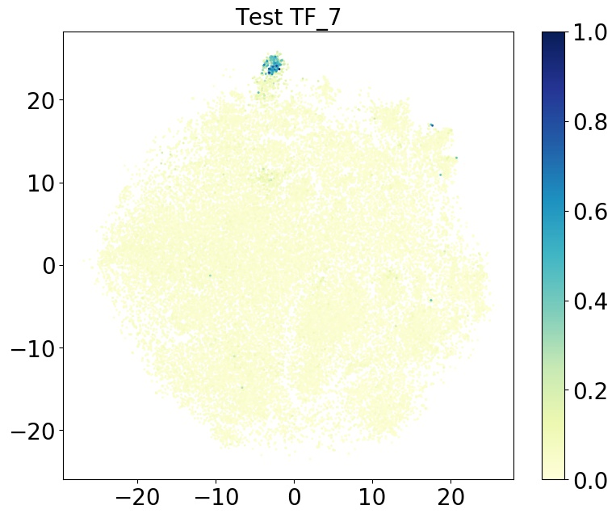

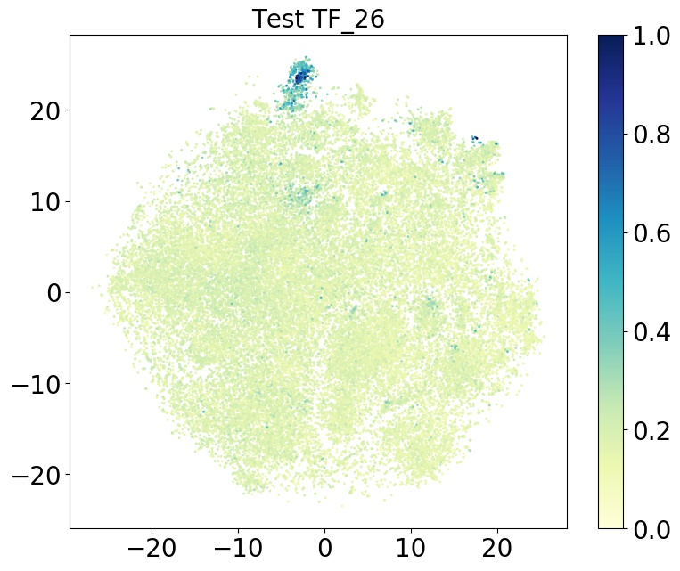

**TF_7: Mlx TF_21: Srebf1 TF_26: Tfec**

TF_7, TF_21: 0.370 TF_7, TF_26: 0.699 TF_21, TF_26: 0.500

**POU**

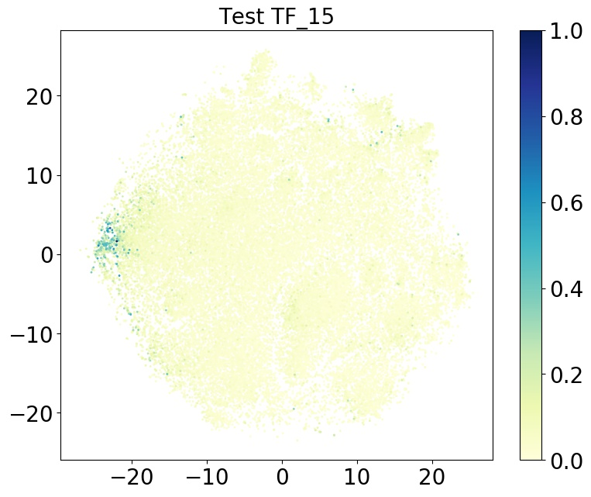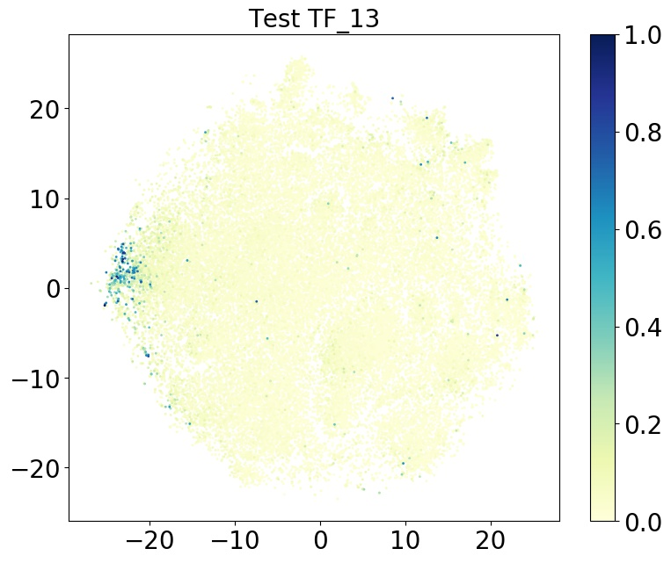

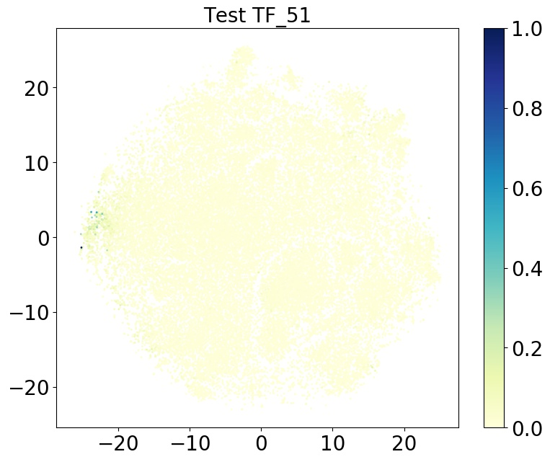

**TF_13: Oct-1 TF_15: Pit1 TF_51: Pou1f1**

TF_13, TF_15: 0.811 TF_13, TF_51: 0.778 TF_15, TF_51: 0.853

**Myb/SANT**

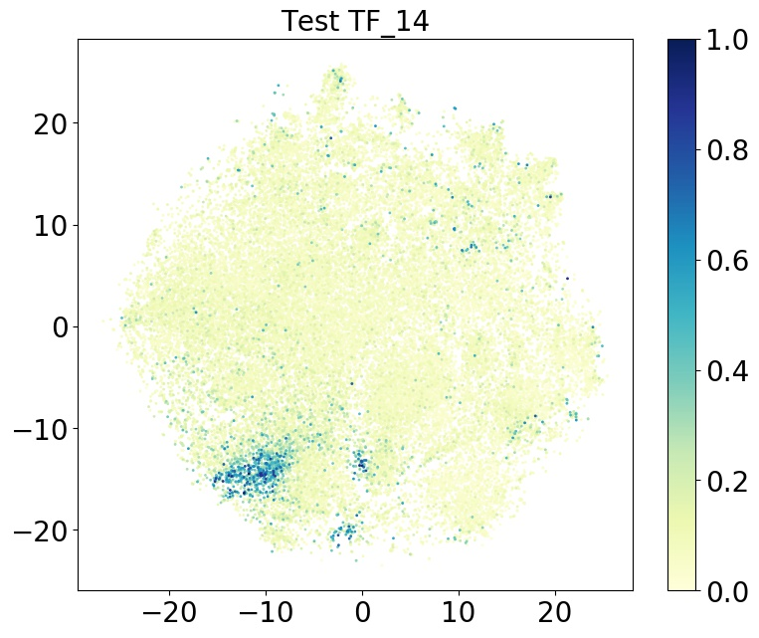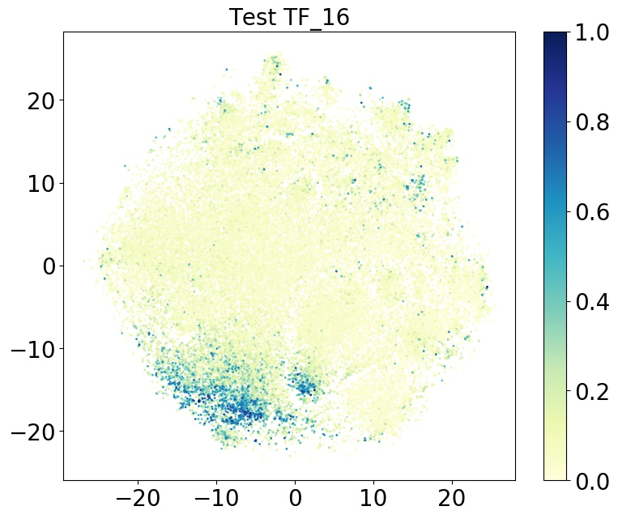

**TF_14: P42pop TF_16: Prdm11**

TF_14, TF_16: 0.414

**Sox**

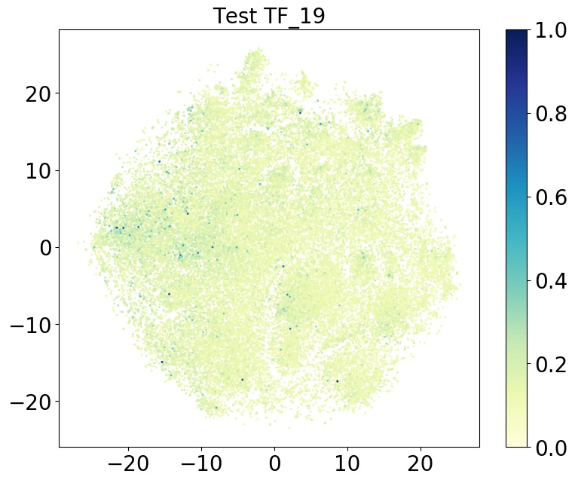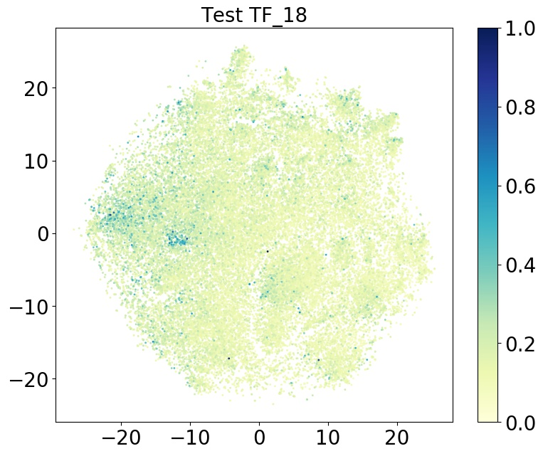

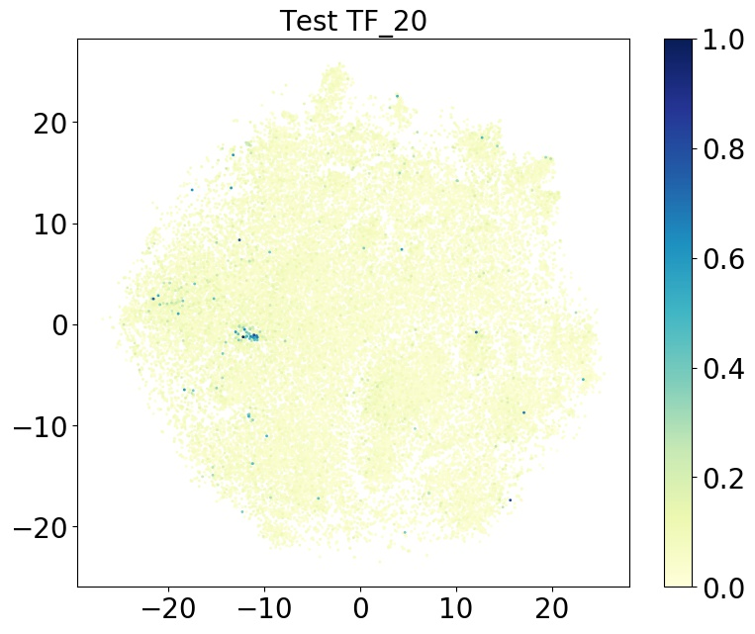

**TF_18: Sox10 TF_19: Sox3 TF_20: Sox6**

TF_18, TF_19: 0.747 TF_18, TF_20: 0.639 TF_19, TF_20: 0.541

**T-box**

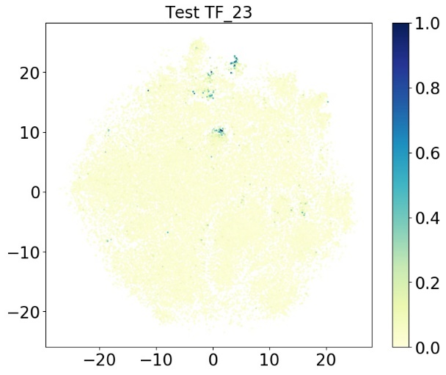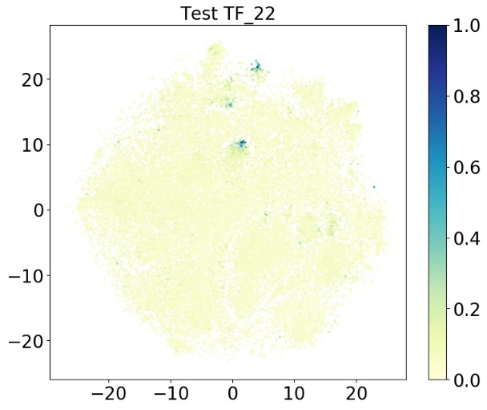

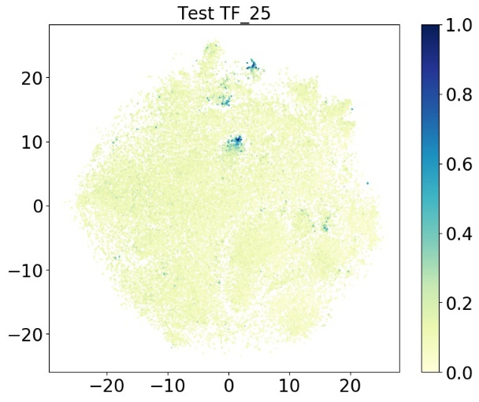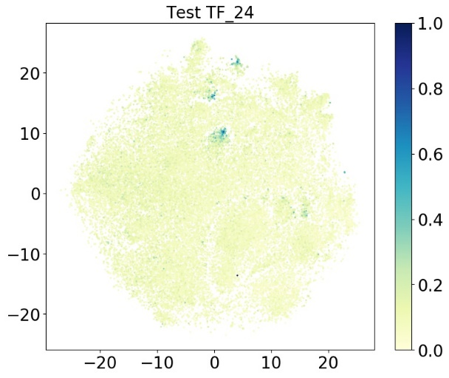

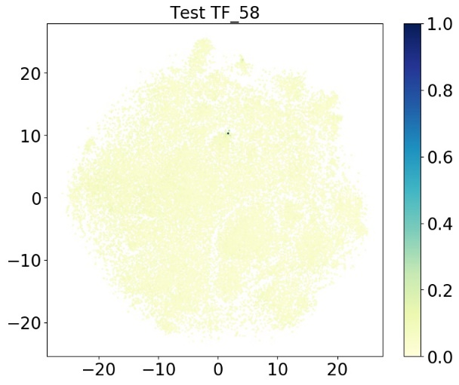

**TF_22: Tbx2 TF_23: Tbx20 TF_24: Tbx4 TF_25: Tbx5 TF_58: Tbx1**

TF_22, TF_23: 0.692 TF_22, TF_24: 0.788 TF_22, TF_25: 0.800

TF_22, TF_58: 0.499 TF_23, TF_24: 0.597 TF_23, TF_25: 0.626

TF_23, TF_58: 0.366 TF_24, TF_25: 0.913 TF_24, TF_58: 0.481

TF_25, TF_58: 0.421

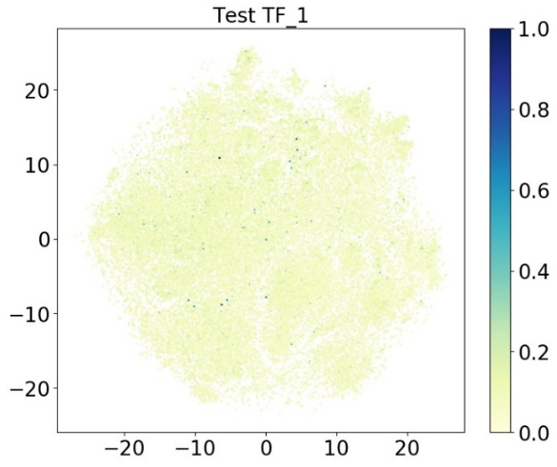**Nuclear receptor**

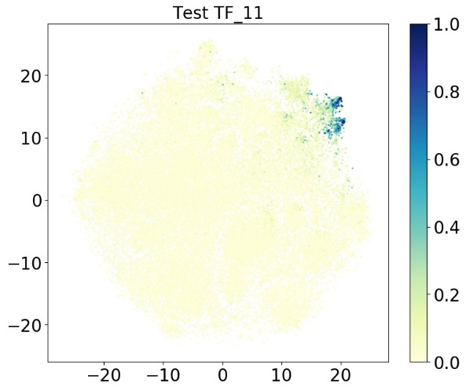

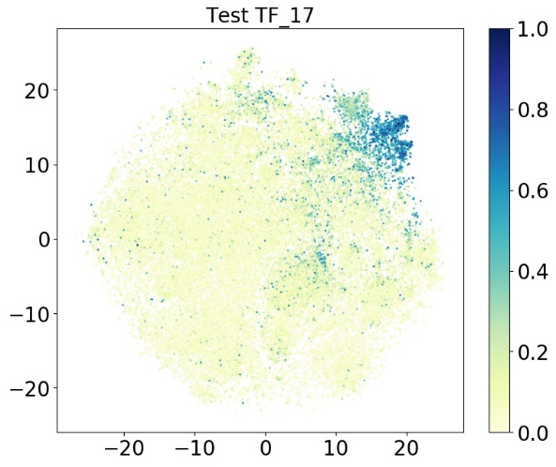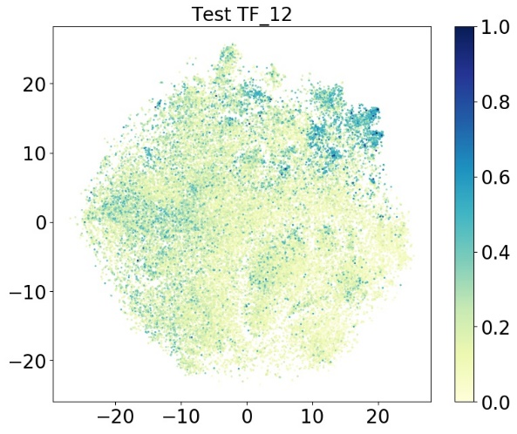

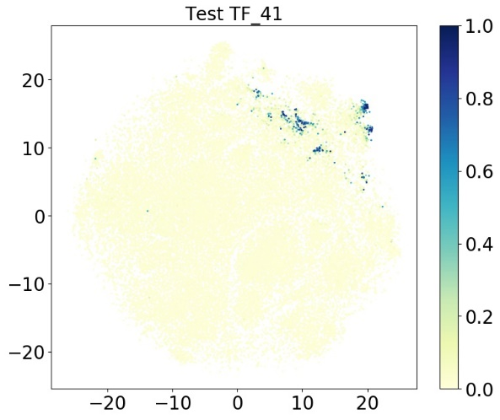

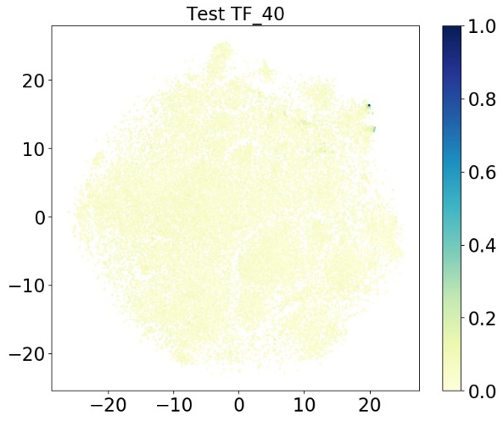

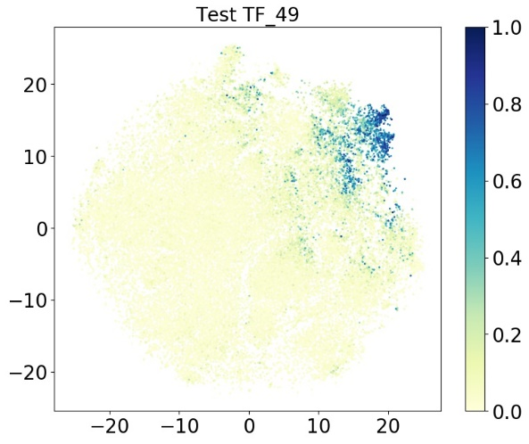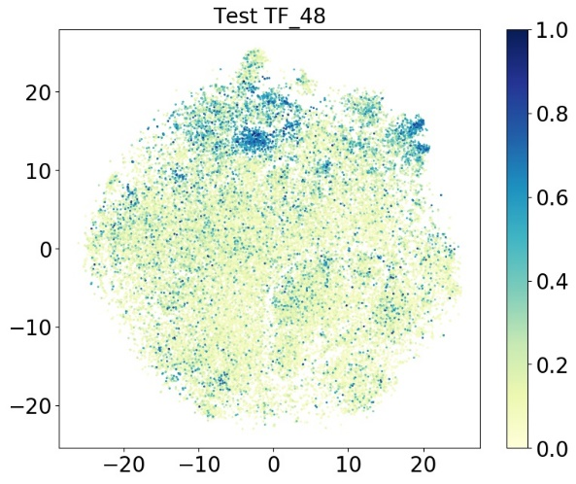

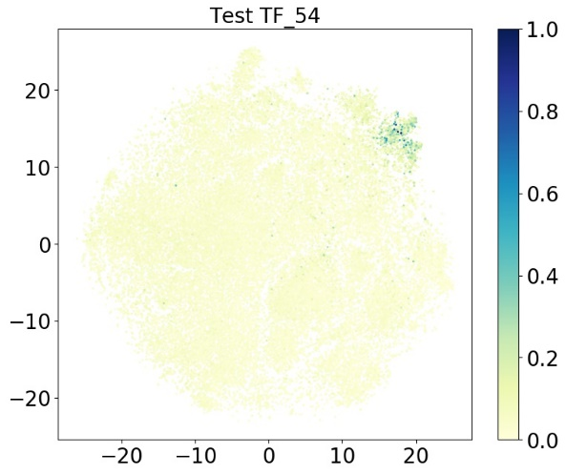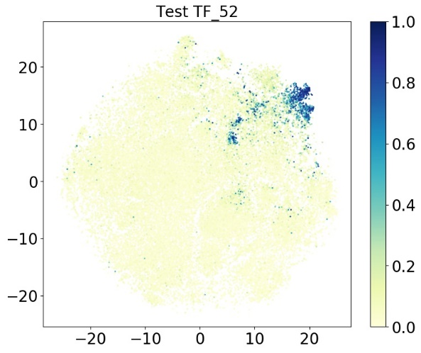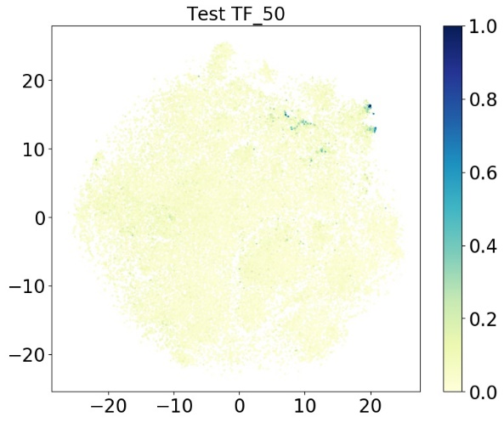

**TF_1: Ar TF_11: Nr2f6 TF_12: Nr4a2**

**TF_17: Rorb TF_40: Esrrb TF_41: Esrrg**

**TF_48: Nr2e1 TF_49: Nr2f1 TF_50: Nr5a2**

**TF_52: Rarg TF_54: Rora**

TF_1, TF_40: 0.457 TF_1, TF_41: 0.0545 TF_1, TF_11: 0.0203

TF_1, TF_12: 0.280 TF_1, TF_48: 0.157 TF_1, TF_17: 0.0397

TF_1, TF_49: -0.0251 TF_1, TF_50: 0.262 TF_1, TF_52: 0.136

TF_1, TF_54: 0.256 TF_40, TF_41: 0.290 TF_11, TF_40: 0.266

TF_12, TF_40: 0.482 TF_40, TF_48: 0.336 TF_17, TF_40: 0.204

TF_40, TF_49: 0.118 TF_40, TF_50: 0.606 TF_40, TF_52: 0.357

TF_40, TF_54: 0.431 TF_11, TF_41: 0.451 TF_12, TF_41: 0.285

TF_41, TF_48: 0.207 TF_17, TF_41: 0.375 TF_41, TF_49: 0.409

TF_41, TF_50: 0.508 TF_41, TF_52: 0.457 TF_41, TF_54: 0.282

TF_11, TF_12: 0.386 TF_11, TF_48: 0.280 TF_11, TF_17: 0.651

TF_11, TF_49: 0.610 TF_11, TF_50: 0.400 TF_11, TF_52: 0.720

TF_11, TF_54: 0.507 TF_12, TF_48: 0.389 TF_12, TF_17: 0.362

TF_12, TF_49: 0.337 TF_12, TF_50: 0.437 TF_12, TF_52: 0.508

TF_12, TF_54: 0.477 TF_17, TF_48: 0.251 TF_48, TF_49: 0.262

TF_48, TF_50: 0.263 TF_48, TF_52: 0.376 TF_48, TF_54: 0.309

TF_17, TF_49: 0.640 TF_17, TF_50: 0.326 TF_17, TF_52: 0.681

TF_17, TF_54: 0.750 TF_49, TF_50: 0.266 TF_49, TF_52: 0.659

TF_49, TF_54: 0.449 TF_50, TF_52: 0.433 TF_50, TF_54: 0.453

TF_52, TF_54: 0.607

**Others**

**GATA Homeodomain**

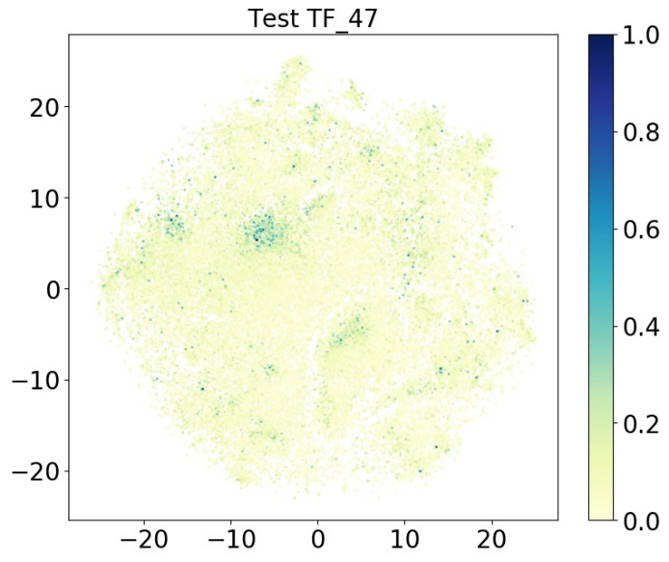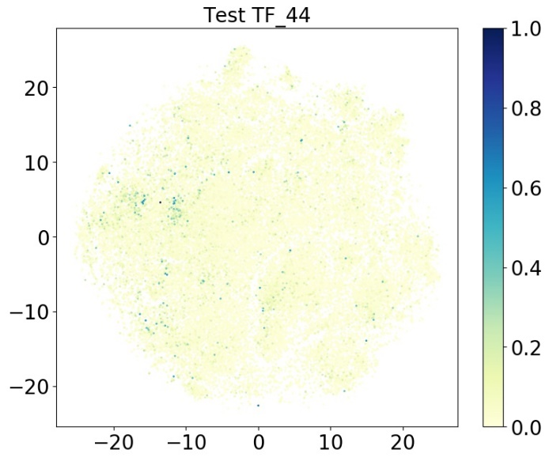

**RFX**

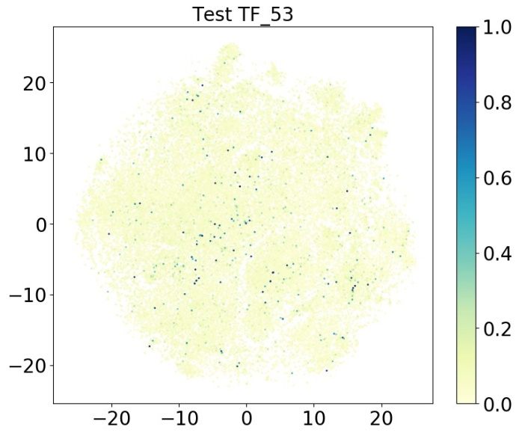

**TF_44: Gata4 TF_47: Nkx2-9 TF_53: Rfx7**